*Common Industry Format for Usability Test Report*

Comments and questions about this format: iusr@nist.gov

Assignment 2 Part 2

Usability Engineering

Website (www.rmit.edu.au)

|  |  |
| --- | --- |
| Test Date | 06-05-2020 |
| Report Date | 15-03-2020 |
| Student name and number | D’Monte Amellia Elizabeth -s3806941 |
| Dwivedi Mansi Narendra -s3816856 |
| Kanojiya Vidhita Kiran - s3833689 |
| Mathur Shubham - s3801882 |
| Rao Nachiket – s3827657 |
| Veni Shantanu – s3798644 |

Table of Contents

Executive Summary 1

Introduction 1

Full Product Description/Overview of site 1

User Profile 2

Scope 2

Test Objectives 2

Method 2

Participants 2

Context of Site/Application Use in Test 3

Tasks …………………………………………………………………………………3

Test Facility 4

Participants Computing Environment 4

Display Devices 14

Experimental Design 5

Procedure 7

Participant Task Instructions 8

Usability Metrics 8

Data Reduction 8

Results 9

Data Analysis 10

Data Scoring 10

Presentation of Results 15

Recommendations 15

Findings 15

Observation 16

Recommendations 17

Overall Conclusion 17

References 18

Appendix A – Data Collection Forms 19

Usability Test Data 19

Consent Forms 19

Observations 19

Test Plan 19

Questionnnaires 19

Videos 19

Appendix B – Screen Shots 20

# Executive Summary

The website under scrutiny is rmit.edu.au. This is the main homepage of Royal Melbourne Institute of Technology (RMIT), a public university in Melbourne Australia, and focuses on giving an overview about the university as well as a landing page for currently enrolled RMIT students. 5 participants were selected for the purpose of testing, all between the age of 18 -30, and each of the participants were given five tasks involving different elements of the website.

**Main Findings:**

**First task** – Get list of international agents in your country –

**Second task** – Find information on student accommodation –

**Third task** – Sync canvas calendar on your device –

**Fourth task** – Create a post on RMIT forum –

**Fifth task** – Search for a post on RMIT community forum –

The test was conducted to evaluate the usability of the following elements of RMIT website

1. RMIT university webpage
2. Canvas
3. Community Forum

# Introduction

## Full Product Description/Overview of site

The website for which the test was conducted is [www.rmit.edu.au](http://www.rmit.edu.au) and is the primary webpage for RMIT university, a public university in Melbourne Australia. The website caters to 2 main groups of people –

1. Prospective students (or education guides) looking for information on the university and various academic courses as well as the kind of infrastructure and services offered by the university
2. Currently enrolled RMIT students who utilize services such as Canvas (a learning management system), community forum, enrolment online (for current and future enrolment needs), RMIT connect (to seek help on anything RMIT related) etc.

## User Profile

The website is aimed at users around the age group of 18 – 40 with a rudimentary knowledge of using an internet browser and navigating websites. The spectrum of intended users of the website is quite broad, ranging from local and international students from various academic backgrounds as well as middle aged people who might either be parents, education guides or professors.

## Scope

Following were the main aspects of the website that were evaluated –

1. **RMIT University website** – Being the primary website of the university, it is crucial that the user can find the required information from the homepage as fast as possible
2. **Canvas** – This is the central landing page for nearly all RMIT students for any academic related information on their course/semester.
3. **Community forum** – A place for students to ask/answer any query they might have related to RMIT.

## Test Objectives

The main objective was to test different sections of the website namely the main university website, canvas and the student community forum.

# Method

## Participants

|  |  |  |  |  |  |
| --- | --- | --- | --- | --- | --- |
| **Participant Number** | **Age** | **Enrolled in RMIT?** | **Area of Study** | **Know how to sync external calendar?** | **Have you heard of RMIT community forum?** |
| 1 | 18-30 | YES | Data Science | YES | YES |
| 2 | 18-30 | YES | Professional Accounting | YES | NO |
| 3 | 18-30 | YES | Aerospace | YES | NO |
| 4 | 18-30 | YES | Data Science | YES | NO |
| 5 | 18-30 | YES | Food and Science Technology | YES | NO |

## Context of Site/Application Use in Test

### Tasks

**Task 1** -

Outcome - Get the list of international agents for a specific country

Scenario – RMIT has affiliations with various international education agents who help students in their application process. You are an international student interested in enrolling at RMIT. Use the RMIT website to find a list of agents and their details based on the selected country.

Background – Given the huge number of international students, finding information on agents in any country should be a straightforward task and is expected to be done anybody who might visit RMIT website.

Success Criteria - User successfully finds the page with a drop-down list of country that will produce the list of agents along with further information including address and phone number

**Task 2** -

Outcome - Explore different student housing and accommodation alternatives near RMIT city campus

Scenario – Using the RMIT website, find out what accommodation options are provided by the university and how close or far are they from the city campus

Background – One of the common queries upcoming university students have is always about accommodations. The university website should include the necessary nearby accommodation details which should be easy to find for any student who aims to find information on the same.

Success Criteria - Webpage displaying accommodation options across different RMIT campuses in Melbourne

**Task 3** -

Outcome - Retrieve URL of the canvas application calendar

Scenario – Using canvas, the learning management system provide by RMIT university, sync the calendar with your device by finding the URL of canvas calendar.

Background – Every student studying at RMIT is required to use their learning management system called Canvas. Given that many students might not be from an IT background, it is important that the application is easy to use and quick to learn. Among other things, canvas maintains its own calendar wherein it stores important dates such as assignment due dates, exam dates and upcoming quiz dates. To make the approach more streamlined, there is an option to sync this calendar with any of the primary digital calendars on the user’s device. The main task here is to see how easy it is to find the URL using the application.

Success Criteria - URL of the canvas calendar

**Task 4** -

Outcome - Create a post on RMIT community forum

Scenario – RMIT community forum is a place where students can ask any queries academic or non-academic related and get help from other students. Make use of the RMIT community forum to start a new discussion thread.

User Data –

* For subject – type “RMIT Usability Test”
* From drop down choose “General Discussion”
* In the body type “Conducting a usability test, please ignore this post”

Background – Community forum is a place where students are free to ask any queries they might have RMIT related and so it should be intuitive enough for a user of any background to be able to easily understand how to do basic tasks such as creating a post. The main goal here is for user to successfully create a new post.

Success Criteria - User has successfully created a new post with the subject and body as specified in the task

**Task 5** -

Outcome – Search for a post in community forum

Scenario – Given the huge number of students, there is a possibility that the query you might have has been asked and answered by another student at a previous time. Make use of the RMIT community forum to search for Wi-Fi related discussions.

User Data –

Type “Wifi” in the search bar

Background – A strong point of any community forum should be its ability to help the user find the required information related to his/her query so as to save time of that user in trying to type in the same query that quite possibly has been already answered. Main goal here is to understand how intuitive the search experience of the RMIT community forum is.

Success Criteria - Any Wi-fi related post or a webpage with the search results relating to Wi-fi.

### Test Facility

Given the unique nature of circumstances, testing was carried out either remotely or in the tester’s home.

### Participants Computing Environment

Computer Model – Lenovo Y 50-70,

Operating System – Windows 10

Mouse – Default laptop trackpad with windows precision drivers

Browser – Google Chrome

Recording Software – ShareX with ffmpeg encoder

## Experimental Design

A total of 5 participants were recruited for the purpose of testing and all of them were handed the same tasks. There were 5 tasks designed to test different aspects of the RMIT website and all the participants were instructed to perform these 5 tasks one after the another. Out of the 5 tasks, 3 tasks required the users to login using their RMIT credentials. Since the participants were recruited on a completely voluntary basis, they were given the choice of leaving or skipping the tasks if at all they felt like it.

**Participant 1:**

**Tasks Completed** - 05(Task1, Task 2, Task 3, Task 4, Task5)

**Time for Each Task** -

|  |  |  |
| --- | --- | --- |
| **User** | **Task** | **Time** |
| 1 | Get list of international agents | 00:03:02 |
| Explore student housing and accommodation | 00:01:19 |
| Retrieve URL of Canvas Calendar | 00:00:43 |
| Create new post using RMIT Community forum | 00:02:22 |
| Search for a post in RMIT Community Forum | 00:00:46 |

**Participant 2:**

**Tasks Completed** - 05(Task1, Task 2, Task 3, Task 4, Task5)

**Time for Each Task** -

|  |  |  |
| --- | --- | --- |
| **User** | **Task** | **Time** |
| 2 | Get list of international agents | 00:01:13 |
| Explore student housing and accommodation | 00:04:00 |
| Retrieve URL of Canvas Calendar | 00:00:22 |
| Create new post using RMIT Community forum | 00:02:12 |
| Search for a post in RMIT Community Forum | 00:00:54 |

**Participant 3:**

**Tasks Completed -** 05(Task1, Task 2, Task 3, Task 4, Task5)

**Time for Each Task –**

|  |  |  |
| --- | --- | --- |
| **User** | **Task** | **Time** |
| 3 | Get list of international agents | 00:02:34 |
| Explore student housing and accommodation | 00:04:06 |
| Retrieve URL of Canvas Calendar | 00:01:04 |
| Create new post using RMIT Community forum | 00:02:20 |
| Search for a post in RMIT Community Forum | 00:01:10 |

**Participant 4:**

**Tasks Completed** - 05(Task1, Task 2, Task 3, Task 4, Task5)

**Time for Each Task** -

|  |  |  |
| --- | --- | --- |
| **User** | **Task** | **Time** |
| 4 | Get list of international agents | 00:03:58 |
| Explore student housing and accommodation | 00:05:02 |
| Retrieve URL of Canvas Calendar | 00:00:42 |
| Create new post using RMIT Community forum | 00:02:12 |
| Search for a post in RMIT Community Forum | 00:00:57 |

**Participant 5:**

**Tasks Completed -** 05(Task1, Task 2, Task 3, Task 4, Task5)

**Time for Each Task –**

|  |  |  |
| --- | --- | --- |
| **User** | **Task** | **Time** |
| 5 | Get list of international agents | 00:04:57 |
| Explore student housing and accommodation | 00:02:34 |
| Retrieve URL of Canvas Calendar | 00:00:46 |
| Create new post using RMIT Community forum | 00:02:01 |
| Search for a post in RMIT Community Forum | 00:00:49 |

### Procedure

The participants were informed beforehand that this test was conducted as a part of our course assignment. Given the unique circumstances due to the ongoing pandemic situation, participants consisted of people within the testers network, mainly close friends, roommates, and colleagues. As such, the participants were not paid or given monetary compensation of any sort. One participant was chosen out of each tester’s network and each test was conducted by that tester who played the role of both the facilitator as well as the observer.

| **Task numbers** | **Time limit (minutes)** | **Assists allowed?** | **Type of assistance** |
| --- | --- | --- | --- |
| 1 | 5 min | Yes | If users were unable to find the required webpage starting from homepage, starting point was changed to How to Apply page |
| 2 | 5 min | Yes | If users were unable to find the required webpage starting from homepage, starting point was changed to Current Students page |
| 3 | 2 min | No | No assistance provided |
| 4 | 3 min | No | No assistance provided |
| 5 | 1 min | No | No assistance provided |

### Participant Task Instructions

**User Task 1** - Use the RMIT website to find a list of agents and their details based on the selected country.

Starting point – RMIT Homepage

**User Task 2** - Using the RMIT website, find out what accommodation options are provided by the university and how close or far are they from the city campus.

Starting point – RMIT Homepage International Students

**User Task 3** - Using canvas, the learning management system provide by RMIT university, sync the calendar with your device by finding the URL of canvas calendar.

Starting Point – RMIT Students Homepage

**User Task 4** - Make use of the RMIT community forum to start a new discussion thread.

Starting Point – Google search homepage

**User Task 5** - Make use of the RMIT community forum to search for Wi-Fi related discussions.

Starting Point – RMIT Community forum

## Usability Metrics

For testing, following metrics were used –

1. Completion Rate
2. Error Rating
3. Goal Achievement
4. Time on Task
5. Observations (user and tester)

Satisfaction was tested by having participants fill out a post-test questionnaire as well as interviewing them completion of the task. Question are listed below –

1. On a scale of 1 to 5, 1 being extremely difficult and 5 being easy, how easy was it to navigate through the RMIT website?
2. On a scale of 1 to 5, 1 being extremely difficult and 5 being easy, how easy was it to find relevant information on the web site?
3. On a scale of 1 to 5, 1 being entirely unhelpful and 5 being very helpful, 3. did you find the design and layout of the website helpful?
4. On a scale of 1 to 5, 1 being extremely difficult and 5 being easy, Were the labels assigned to the links easy to understand?
5. How likely would you be to recommend community forum to someone? Why or why not
6. Out of all the tasks, which was the most difficult for you to accomplish?
7. What was the biggest issue while doing tasks in general?
8. How tired are you right now?

**Legend**

Completion Rate Error Rate

C - Completed without assistance C - Completed without Errors

CA - Completed with assistance CE - Completed with Errors

PC - Partially completed E - Not completed

NC - Not completed

### Data Reduction

The tasks have been created with the focus of analysing information on student services provided in the RMIT website:

* The first two tasks test the availability of relevant information for potential students
* The third task tests the accessibility of RMIT canvas calendar
* The fourth and the fifth task evaluate usability of the RMIT community forum

# Results

## Data Analysis

### Data Scoring

Completion Rates

|  |  |  |  |  |  |  |  |
| --- | --- | --- | --- | --- | --- | --- | --- |
| **Task type** | | **Task 1** | **Task 2** | **Task 3** | **Task 4** | **Task 5** |  |
| **Assistance Rating** | **User 1** | **C** | **C** | **C** | **C** | **C** | **Average** |
| **User 2** | **CA** | **NC** | **C** | **C** | **C** |
| **User 3** | **NC** | **CA** | **C** | **C** | **C** |
| **User 4** | **C** | **C** | **C** | **C** | **C** |
| **User 5** | **PC** | **C** | **C** | **C** | **C** |
|  | | | | | | |
| **Scores** | **C** | **2** | **3** | **5** | **5** | **5** |
| **CA** | **1** | **1** | **0** | **0** | **0** |
| **PC** | **1** | **0** | **0** | **0** | **0** |
| **NC** | **1** | **1** | **0** | **0** | **0** |
| **Success** | | **60%** | **80%** | **100%** | **100%** | **100%** | **88%** |
| **Gave up** | | **40%** | **20%** | **0%** | **0%** | **0%** | **12%** |

**Legend**

C - Completed without assistance

CA - Completed with assistance

PC - Partially completed

NC - Not completed

**Error rating**

|  |  |  |  |  |  |  |  |
| --- | --- | --- | --- | --- | --- | --- | --- |
| **Task type** | | **Task 1** | **Task 2** | **Task 3** | **Task 4** | **Task 5** |  |
| **Error Rating** | **User 1** | **C** | **C** | **C** | **C** | **C** |
| **User 2** | **C** | **E** | **C** | **C** | **C** |
| **User 3** | **E** | **C** | **C** | **C** | **C** |
| **User 4** | **C** | **C** | **C** | **C** | **C** |
| **User 5** | **CE** | **C** | **C** | **C** | **C** |
|  | | | | | | |
| **Scores** | **C** | **3** | **4** | **5** | **5** | **5** |
| **CE** | **1** | **0** | **0** | **0** | **0** |
| **E** | **1** | **1** | **0** | **0** | **0** | **Average** |
| **Success without errors** | | **80%** | **90%** | **100%** | **100%** | **100%** | **94%** |
| **Success with errors** | | **10%** | **0%** | **0%** | **0%** | **0%** | **2%** |
| **Not completed** | | **10%** | **10%** | **0%** | **0%** | **0%** | **4%** |

**Error Rating**

C - Completed without Errors

CE - Completed with Errors

E - Not completed

**Task Completion Times**

|  |  |  |
| --- | --- | --- |
| **User** | **Task** | **Time** |
| 1 | 1 | 00:03:02 |
| 2 | 00:01:19 |
| 3 | 00:00:43 |
| 4 | 00:02:22 |
| 5 | 00:00:46 |
| 2 | 1 | 00:01:13 |
| 2 | 00:04:00 |
| 3 | 00:00:22 |
| 4 | 00:02:12 |
| 5 | 00:00:54 |
| 3 | 1 | 00:02:34 |
| 2 | 00:04:06 |
| 3 | 00:01:04 |
| 4 | 00:02:20 |
| 5 | 00:01:10 |
| 4 | 1 | 00:03:58 |
| 2 | 00:05:02 |
| 3 | 00:00:42 |
| 4 | 00:02:12 |
| 5 | 00:00:57 |
| 5 | 1 | 00:04:57 |
| 2 | 00:02:34 |
| 3 | 00:00:46 |
| 4 | 00:02:01 |
| 5 | 00:00:49 |

|  |  |
| --- | --- |
| **Task** | **Mean Time** |
| 1 | 03:09 |
| 2 | 03:24 |
| 3 | 00:43 |
| 4 | 02:13 |
| 5 | 00:55 |

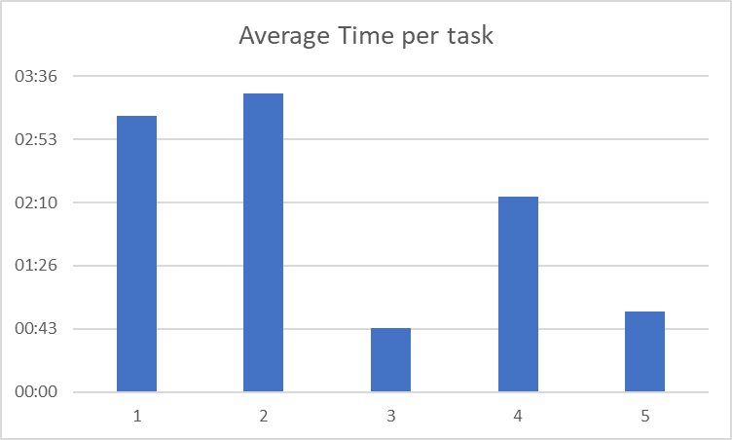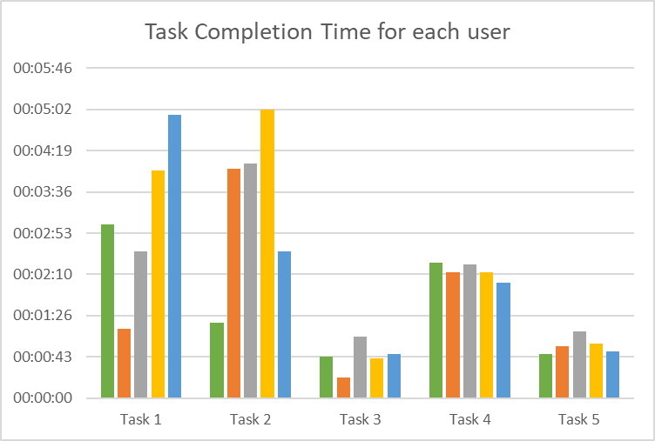

**Satisfaction Scoring (Post-test Questionnaire Results)**

|  |  |  |  |  |  |  |
| --- | --- | --- | --- | --- | --- | --- |
| **Participant** | **Question 1** | **Question 2** | **Question 3** | **Question 4** | **Question 5** | **Question 6** |
| **1** | 3 | 4 | 3 | 3 | 4 | 4 |
| **2** | 2 | 2 | 1 | 1 | 4 | 2 |
| **3** | 2 | 1 | 2 | 2 | 3 | 3 |
| **4** | 4 | 4 | 3 | 3 | 4 | 4 |
| **5** | 4 | 3 | 4 | 3 | 5 | 3 |

Summary of remaining questions

1. How likely would you be to recommend community forum to someone?

Why or why not?

* + I would highly recommend the community forum to others since it was very easy to create and not time consuming.
  + It was very easy to create and search for a post.
  + It was very easy to create the post in community forum and not time consuming. Also getting familiarise with the community forum was easy.
  + I've never heard of the forum and am not very familiar with it. Moreover, it didn't seem to be a very active page as every question had only some replies.
  + It seemed to be a good forum to represent my views or ask questions.

1. Out of all the tasks, which was the most difficult for you to accomplish?
   1. Find international agents
   2. Look for student accommodation
   3. Sync your canvas calendar
   4. Create a new post on the community forum
   5. Search for a post on the community forum

3/5 users chose option a

2/5 users chose option b

1. What was the biggest issue you faced while carrying out that task?
   * Spent a lot of time searching for the accommodation page and the link labels were not very easy to understand.
   * Couldn't find it at all, I checked every link in the international student's section, but accommodation page wasn't there.
   * Had some idea about the agent reference, but it was very confusing to find exactly where it was located and could not easily be analysed.
   * I tried to use the search bar for this task, but the results didn't seem to be the correct ones
   * None of the tasks was quite complicated, but the task of international agents was time consuming.

**Summary of Observer Observations:**

**User 1:**

* + Could mostly complete all tasks without any difficulty
  + Seemed to be confused in the first task and kept scrolling through the same page every time.
  + Only user who found the direct link to the second task

**User 2**:

* + Was confused with the links
  + Needed assistance (a hint) with the first task
  + Checked out every tab in international students but was not thorough with it
  + Seemed frustrated and eventually moved on to the next task without completing task 2
  + Completed the next three tasks easily

**User 3:**

* + Used the search bar for both the first and second tasks
  + Search bar did not give any relevant results for task 1 leading the user to abandon the task
  + For the task 2, after getting a broken link, the user tried to navigate manually through the website to finish the task and needed assistance for the same.
  + Expected the accommodation page to be in Student Essentials or Student Life and kept scrolling through it repeatedly
  + Completed the other three tasks with no issues

**User 4:**

* + Took time to finish the tasks, but did so without making errors or requiring any assistance
  + Checked out every link thoroughly for task 2, also used the search bar to find accommodation page
  + Expected the accommodation to be on the home page of current students and kept scrolling through it
  + Even after eventually moving to the side panel, Student Essentials and Student Life were the only ones that the user checked out before deciding to use search bar
  + Expected to get the correct page using ‘accommodation’ in the search bar but got an incorrect link. Finally found the correct page using ‘housing’
  + Took the long route for the first two tasks but finished the other three with no problems

**User 5:**

* + For the first task, comparatively took a long time and ultimately arrived on the wrong page but thought had completed the task successfully
  + Mentioned familiarity with RMIT accommodation page and easily completed task 2
  + Faced no issue with the other three tasks

### 

## Presentation of Results

**Crucial Problems**

* Frustrating navigation
* Broken links returned by search bar
* Complicated navigation
* Incorrect breadcrumb trail

**Affinity Diagram**

|  |
| --- |
| **RMIT Students Homepage** |
| Incorrect breadcrumb trail |
| Accommodation expected in homepage |

|  |
| --- |
| **RMIT Homepage** |
| Broken links returned |
| Frustrating navigation |

## Recommendations

**Findings**

Task 1 –

* Navigation through main homepage proved to be difficult
* Search bar was unhelpful

Task 2 –

* Users expected a direct link to accommodation from the student's homepage
* Layout of breadcrumb trail is not proper

Task 3 –

* This was done smoothly, however, few users agree that “Calendar Feed” does not make much sense

Task 4 & 5 –

* Done without any hurdles

**Observations**

The major challenges observed in the experiment were due to the confusing nature of navigation adopted by the website. The way data is categorized led to some users navigating aimlessly. Despite the website consisting of a good network of interconnected links, users were observed to face difficulty in finding the correct link to complete the task successfully and without errors.

Tasks 1 and 2 proved to be difficult and time consuming for the users. Most users ended up browsing aimlessly until finding the correct page. A few users tried to take help of the search bar, however, after observing the lack of relevant search results (including one broken link), were left dissatisfied.

User 1 seemed to be aware of where the agents’ information page (refer task 1) should be but was still unable to understand how to use the links and navigation panel to reach there.

User 2 ended up not understanding where to begin at all and eventually asked the facilitator for help.

User 3 tried to use the search bar for completing the task but got no relevant results.

User 4 managed to complete the task but took a lot of time and went through a lot of unnecessary links and pages to reach there.

User 5, on the other hand, got to the correct penultimate page, however got confused with which link to select and ended up choosing the wrong link and finished the task at an incorrect page.

For task 2, where the users were asked to locate the accommodation page, only the users (User 1 and User 5), somewhat familiar with the working of the website, were able to effortlessly finish the tasks.

User 2 browsed through different RMIT campuses trying to find a page related to accommodation but in the end decided to move on to the next task leaving task 2 unfinished.

User 3 asked the facilitator for assistance and then scrolled through the Student essentials and Student Life in search for accommodation page, later deciding to go through every link thoroughly to find the accommodation page.

User 4, similarly, seemed to believe that the page would either be in Student homepage or Student Life/Student Essential. After scrolling through all three pages thoroughly, user 4 decided to use the search bar but found the wrong page. It was only after the user decided to modify the search keyword to ‘housing’, that the user managed to complete the task.

Both User 3 and User 4 highlighted issues with the search bar, which proved to be useless when searching for pages in the website. Both times User 3 used the search bar, they found no relevancy in the results offered by the website.

User 4 on the other hand, realised that even though the page title of task 2 completion page was ‘Accommodation Options’, yet the keyword to get the website was ‘housing’, a random synonym.

Task 3 which required the users to get the calendar link from canvas, showed familiarity that each user had with the canvas website. Every user found it easy and straight-forward to complete this task.

Like task 3, tasks 4 and 5 were relatively easy for the users to finish. The challenge arose, instead on the facilitator’s end, when we realised that there was no way to reach to the community forum through the RMIT website, forcing us to change the start point to the google homepage. When asked, all users seemed to find community forum a novel, but ultimately helpful forum where they could have discussions with fellow students. However, user 3 noticed that the forum did not seem to be particularly known, thus doubting the forum’s integrity. They seemed to find the lack of accessibility from RMIT homepage to be suspicious.

**Recommendations:**

RMIT Homepage –

* Remove/Update the broken link search result when user searches for accommodation
* Optimize search results

RMIT Students –

* Provide a link for accommodation in the homepage
* Change the location of the accommodation page with respect to the breadcrumb trail

RMIT Canvas –

* Include a section that might help non-IT students understand how to sync the calendar

**Overall Conclusion**

To summarize, the RMIT website is designed quite well but needs a few adjustments in certain areas as listed by the recommendations above.

# 

# References

# Usability Metrics

* + <https://usabilitygeek.com/usability-metrics-a-guide-to-quantify-system-usability/>
  + <https://www.nngroup.com/articles/usability-metrics/>
* **Qualitative and Quantitative Data**
  + <https://www.usability.gov/how-to-and-tools/methods/reporting-usability-test-results.html>
* **Usability Tests**
  + <https://www.nngroup.com/articles/measuring-perceived-usability/>
* **Usability Test Recording**
  + <https://getsharex.com/>

# Appendix A – Data Collection Forms

### Usability Test Data

* <https://drive.google.com/drive/folders/11eC7rPaf6c9B1wraWPCCFjwZnKhyTRl7?usp=sharing>

### Consent forms

* <https://drive.google.com/open?id=1SqpOH2-2MXf2gbvKppDKbA6NSFGJHvJO>

### Observations

* <https://drive.google.com/open?id=1d0G96OT6xmPI0Robmp0zDsHQGenoENfL>

### Test Plan

* <https://drive.google.com/open?id=1v9dkIATyJA_1BuSgV5U7X4S8VPEn_bSG>

### Questionnnaires

* <https://drive.google.com/open?id=1ZvgSMz-PbMcNM-gmU_1B2vaFkZ33IY0d>

### Videos

* <https://drive.google.com/open?id=1YOHdv3rx-T2NrpJ0LimjMBGj7Dx9o4Ai>

# Appendix B – Screen Shots

* Unhelpful search results from search bar

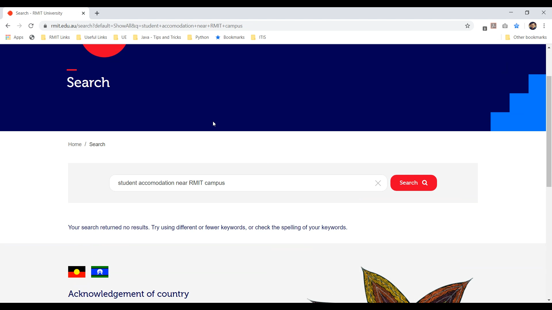

* Broken link for accommodation through main website

